Terraform Task-2

Task Description:

Create 2 EC2 instances on 2 different regions and install nginx using terraform script.

Techstacks needs to be used :

- AWS EC2
- Terraform
- AWS CLI

Terraform Plan Cmd:

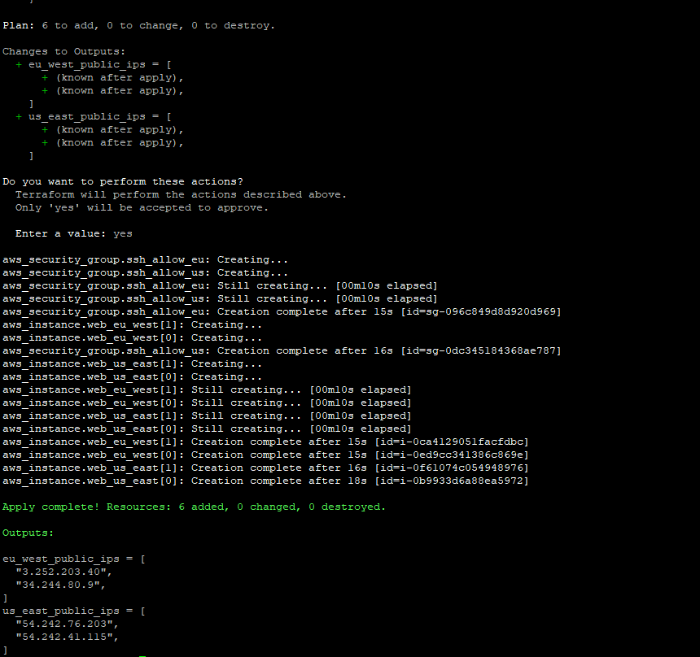
Created 2 EC2 instances on 2 different regions and installed nginx using terraform script.
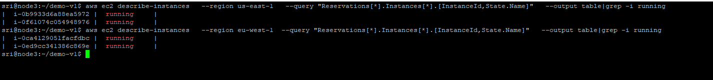
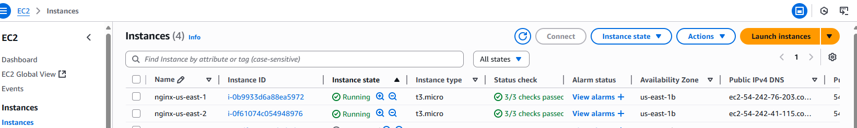
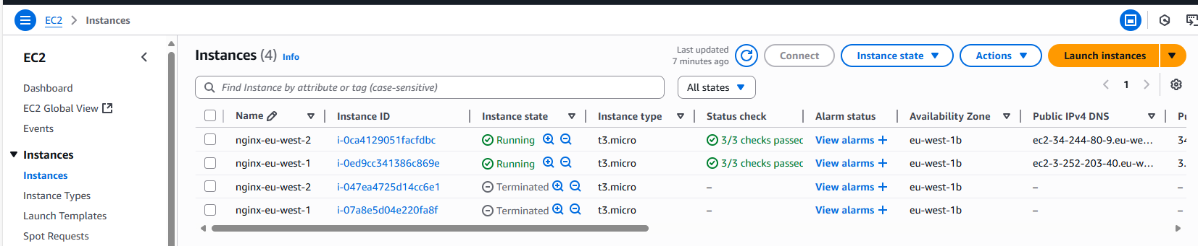
Ngnix Output:
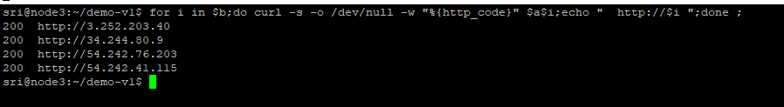
Terraform Code:
terraform {
required_providers {
aws = {
source = "hashicorp/aws"
version = ">= 4.0"
}
}
required_version = ">= 1.0"
}

########################
# Provider definitions #
########################

# Provider for Region A (example: us-east-1)
provider "aws" {
alias = "us_east_1"
region = "us-east-1"
}

# Provider for Region B (example: eu-west-1)
provider "aws" {
alias = "eu_west_1"
region = "eu-west-1"
}

####################
# Input variables #
####################
variable "instance_type" {
type = string
default = "t3.micro"
}

variable "key_name" {
type = string
default = "my-keypair" # change to your actual keypair name
}

variable "ami_us_east_1" {
type = string
# Use a valid AMI for us-east-1 (Ubuntu 22.04 LTS)
default = "ami-0fc5d935ebf8bc3bc"
}

variable "ami_eu_west_1" {
type = string
# Use a valid AMI for eu-west-1 (Ubuntu 22.04 LTS)
default = "ami-0bc691261a82b32bc"
}

##########################################
# User data script to install Nginx
##########################################
locals {
nginx_user_data = <<-EOF
#!/bin/bash
apt update -y
apt install -y nginx
systemctl enable nginx
systemctl start nginx
echo "Hello from $(hostname)" > /var/www/html/index.html
EOF
}

########################
# Security Groups
########################

resource "aws_security_group" "ssh_allow_us" {
provider = aws.us_east_1
name = "allow_ssh_http_us"
description = "Allow SSH and HTTP from anywhere"

ingress {
from_port = 22
to_port = 22
protocol = "tcp"
cidr_blocks = ["0.0.0.0/0"]
}

ingress {
from_port = 80
to_port = 80
protocol = "tcp"
cidr_blocks = ["0.0.0.0/0"]
}

egress {
from_port = 0
to_port = 0
protocol = "-1"
cidr_blocks = ["0.0.0.0/0"]
}
}

resource "aws_security_group" "ssh_allow_eu" {
provider = aws.eu_west_1
name = "allow_ssh_http_eu"
description = "Allow SSH and HTTP from anywhere"

ingress {
from_port = 22
to_port = 22
protocol = "tcp"
cidr_blocks = ["0.0.0.0/0"]
}

ingress {
from_port = 80
to_port = 80
protocol = "tcp"
cidr_blocks = ["0.0.0.0/0"]
}

egress {
from_port = 0
to_port = 0
protocol = "-1"
cidr_blocks = ["0.0.0.0/0"]
}
}

####################
# EC2 Instances
####################

# Instance(s) in us-east-1
resource "aws_instance" "web_us_east" {
count = 2
provider = aws.us_east_1
ami = var.ami_us_east_1
instance_type = var.instance_type
key_name = var.key_name
user_data = local.nginx_user_data

vpc_security_group_ids = [aws_security_group.ssh_allow_us.id]

tags = {
Name = "nginx-us-east-${count.index + 1}"
Region = "us-east-1"
}
}

# Instance(s) in eu-west-1
resource "aws_instance" "web_eu_west" {
count = 2
provider = aws.eu_west_1
ami = var.ami_eu_west_1
instance_type = var.instance_type
key_name = var.key_name
user_data = local.nginx_user_data

vpc_security_group_ids = [aws_security_group.ssh_allow_eu.id]

tags = {
Name = "nginx-eu-west-${count.index + 1}"
Region = "eu-west-1"
}
}

####################
# Outputs
####################
output "us_east_public_ips" {
value = aws_instance.web_us_east[*].public_ip
}

output "eu_west_public_ips" {
value = aws_instance.web_eu_west[*].public_ip
}

